**Pub-Xel User Manual**

Please note that Pub-Xel is currented supported in Windows only.

**Rationale:**

Biomedical researchers often must handle hundreds, even thousands of biomedical articles throughout their research career. Pub-Xel is for those who want quick, efficient, and easy measure to organize biomedical articles. Pub-Xel is a support software designed to enable users to manage their biomedical literature in Microsoft Excel spreadsheets.

**What to expect:**

With Pub-Xel, you can:

* Manage your biomedical references in Excel spreadsheet
* Import article information (e.g., authors journal, impact factor) from PubMed to Excel
* open article pdfs / supplemental files from Excel
* open article pdfs / supplemental files from anywhere, like ppts or word manuscript
* Manipulate article files

With Pub-Xel, you can finally manage your library of literature in the most straightforward way you have not imagined before.

**How to use**

**Step 0. Settings**

Open Pub-Xel.exe. A screen will pop up. Leave it turned on throughout your work. Press “Exit” if you want to exit later.

*Pub-Xel.exe screen*

Find the article of your interest in PubMed. Download the article pdf file. Name the file by its PMID, and place the file in “article_library” folder in your Desktop. Then you are all set.

*saving pdf files*

**Step 1. Import data to Excel**

Open the excel template file. Rename and save it as you please. In the Excel sheet, at the first column, list the PMID of your references. Then, select the Excel cells containing PMIDs. Go to Pub-Xel and click “Import PubMed Data.” The rest of the excel columns will be filled with the data, including first author, year, journal, abstract, and 2022 impact factor.

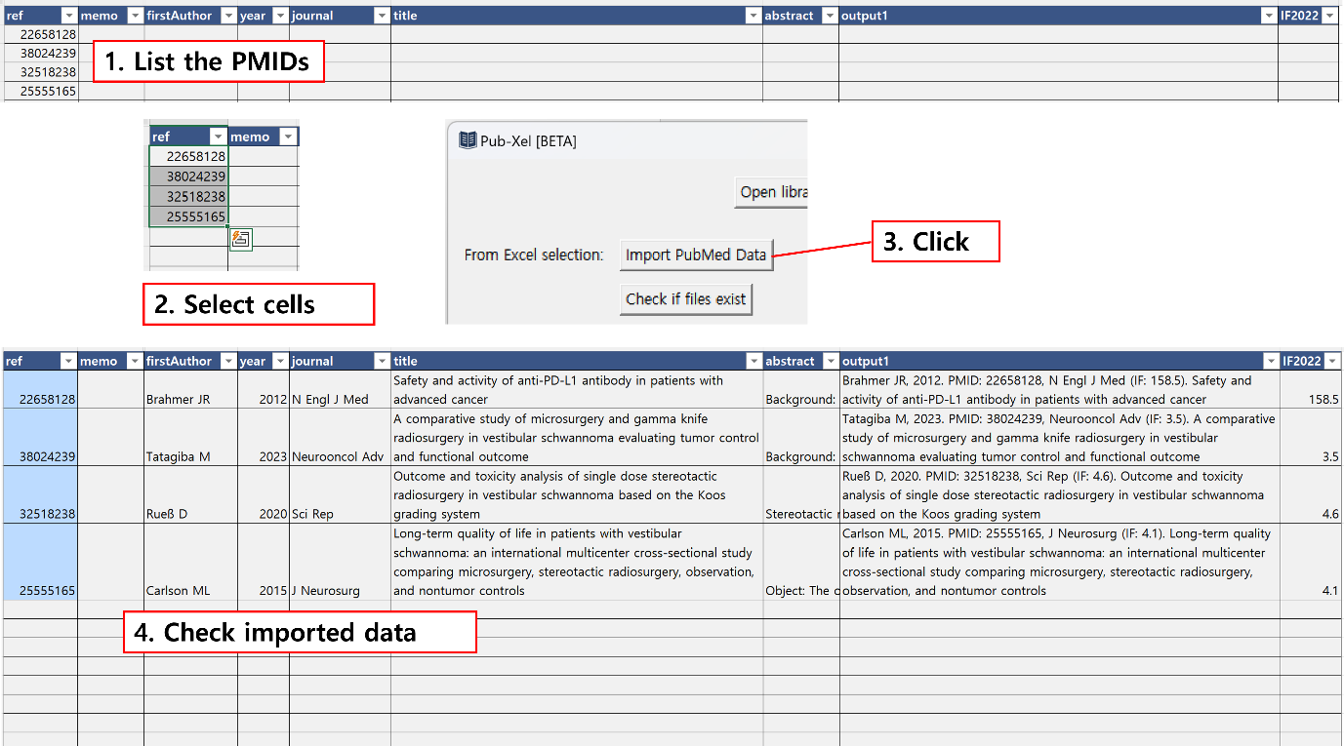

*Importing article data from PubMed*

Doing so will also give you a neat citation form in “output1” column. Copy and paste it wherever you need to present a reference for the article in your ppts.

Pub-Xel will also check whether you have the article (pdf) file corresponding to the PMIDs in the Excel cells. The cells will turn blue if you have them. You can repeat just this action more quickly by selecting the cells and clicking “Check if files exist” button in Pub-Xel.

**Step 2-1. Open article file**

Select the cell containing PMID and copy it (Ctrl + C). Once the PMID is copied to the clipboard, you can open it whenever you want, by pressing “Open files” button or simply pressing the hotkey (Ctrl+shift+K).

*Opening a file from clipboard*

You can also open multiple pdf files in this way. Just select multiple cells, copy them, and click “Open files” button or press the hotkey (Ctrl+shift+K).

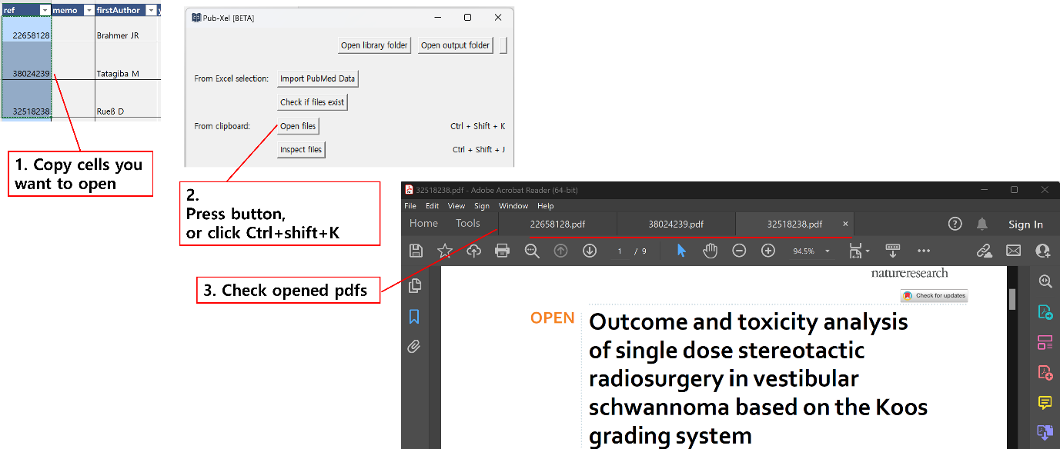

*Opening multiple files from clipboard*

Note that to open files from the clipboard, You don’t have to copy the PMID from the Excel file. but from anywhere.

*You can copy PMID from anywhere (e.g., your ppt file reference) and open it, using hotkeys (Ctrl+shift+K).*

**Step 2-2. Open supplementary files**

You can save supplementary files of an article and manage them with PubXel. Download supplementary files of a PubMed article and name them in this format: “PMID xxx”. For example, “22658128 disclosures” or “22658128 protocol” or “22658128 suppl”. Save them in “article_library” folder. Then your supplements are ready.

*Saving supplementary files*

After copying the PMID(s), click “Inspect files” button or press its hotkey (Ctrl+shift+J). A screen will pop up, showing the list of associated main files and supplementary files. Check the files you want and press “Open Selected” to open files.

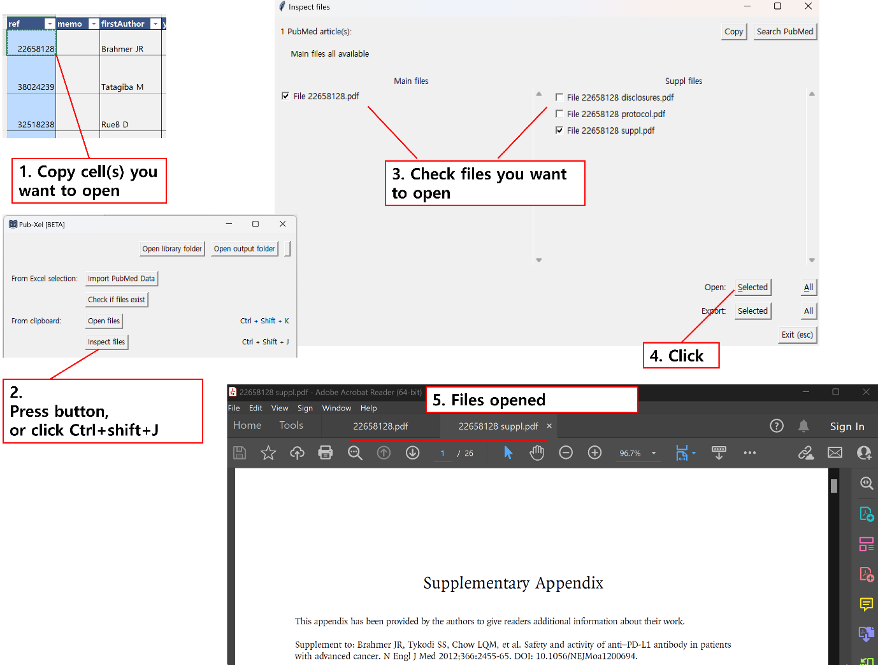

*Opening main and supplementary files*

**Step 2-3. Send files somewhere else**

You might need to send some of the pdf files to another device or another person. Copy the relevant PMIDs in the excel file, and then click “Inspect files” button or press its hotkey (Ctrl+shift+J). Check the files you want to send, and press “Export Selected”. The copy of the files will be presented at “article_output” folder in your desktop.

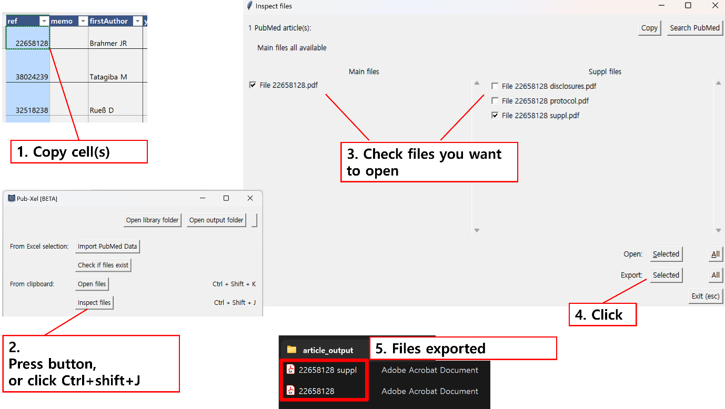

*Exporting article files*

**Step 2-4. Managing non-PubMed articles**

You can manage non-PubMed articles or files in the same manner. Save the article files in “article_library” by a unique name, and use that name as an ID to identify the article. Just one thing: you must make sure that non-PubMed file name does not start with a number. If it starts with a number, Pub-Xel will identify that file as a supplementary material of a PubMed article.

**Step 3. There is more…**

Pub-Xel is currently in its beta version. Version 1 will be launched at July 2024, freely available for biomedical researchers worldwide. More features are yet to come (MacOS support, import citation count, auto-download pdf files, …). Please feel free to **send any bug reports, suggestions, and your thoughts to** [**crossing96@gmail.com**](mailto:crossing96@gmail.com)**.** I appreciate your participation in the beta version.